**ANGHARAD JENKINS & PATRICK RIMES**

**‘amrwd’**

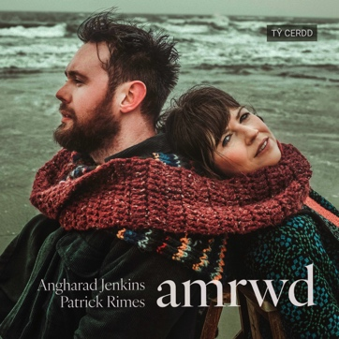

released on Tŷ Cerdd Records (TCR042)

**4 August 2023**

Live show:

**6 August National Eisteddfod of Wales**

***"amrwd****encapsulates the sound of our strings, our voices, with foot percussion and keys. The presentation is raw, stripped-back, pure and simple.”*

***amrwd*** (the Welsh for *raw*) is the debut album from two artists who are simply at the top of their game on the Welsh folk scene. As founding members of the multi award-winning band CALAN, **Angharad Jenkins** and **Patrick Rimes** (also a founding member of Vrï) have spent fifteen years at the cutting edge of Welsh traditional music, constantly bending and beating it into unfamiliar shapes with their relentlessly innovative interpretations of old repertoire. Through five studio albums and gruelling tours across three continents a deep musical rapport has grown, a shared instinctive musical language and a yearning to hear these ancient melodies as they are: raw and unfiltered.

*amrwd* will be released on Tŷ Cerdd Records on **4 August** with a live show at and [**National Eisteddfod of Wales**](https://eisteddfod.wales/2023-ll%C5%B7n-ac-eifionydd) on **6 August**.

Despite both having extremely broad, multi-instrumental and genre-hopping musical portfolios, Angharad and Patrick are primarily associated with the Welsh fiddle tradition – a style which they have both helped to shape in their own ways in recent years. In *amrwd* we hear the unadulterated earthy sound of the strings as both fiddles circle each other in a lively conversation, as well as the pair’s rich singing voices (in both Welsh and English) – garnished with occasional foot percussion and piano.

Although *amrwd* is a debut record for this duo, it has been forged over many years spent honing their craft, mining the archives for tunes and songs, and discovering the secrets of their tradition. Old favourites such as ‘Myfanwy’, ‘Calon Lân’ and ‘Tra Bo Dau’ sit alongside pieces that slipped further out of Wales’ musical memory – from rousing dance tunes such as ‘Du Fel y Glo’ to the agricultural work song ‘Gyrru’r Ychen’. These traditional songs are complemented by several original compositions from Angharad. As the duo explain, *"We’ve arranged old favourites with sensitivity and respect, playing them alongside our own celebratory joyous fiddle tunes – some imbued with influences from the music we’ve picked up on travels over the years.”*

With classical echoes this deceptively simple album explores some of Wales’ rich folk tradition by two of the country’s most revered practitioners. As a duo they take their love and knowledge of Welsh folk music to new levels of intimacy, with vibrant playing and beautiful vocal harmonies.

**All press enquiries to Riotsquad Publicity:**

Siân Williams (ph) 020 7223 7441 (e) [sian@riotsquadpublicity.com](mailto:sian@riotsquadpublicity.com)

Julie Allison (ph) 01273 475980 (e) [Julie@riotsquadpublicity.com](mailto:Julie@riotsquadpublicity.com)

 

**Notes to editors**

**Tŷ Cerdd Records**

Tŷ Cerdd Records is a label dedicated to promoting Welsh music, driven by Tŷ Cerdd / Music Centre Wales.

Tŷ Cerdd's mission is to support artists, communities and audiences to create, perform and participate in the music and Wales.

[www.tycerdd.org](http://www.tycerdd.org)